**DENDROGRAM FOR THE AVAILABILITY OF THE CONTRACEPTIVE COMMODITIES**

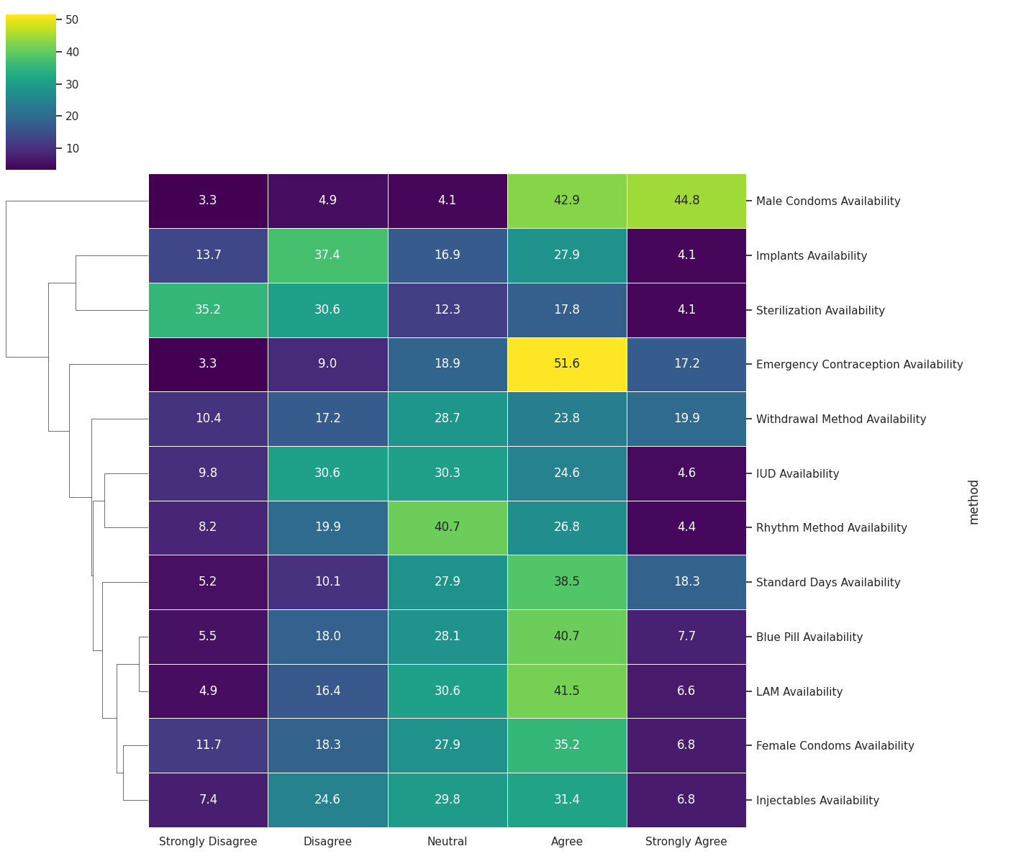

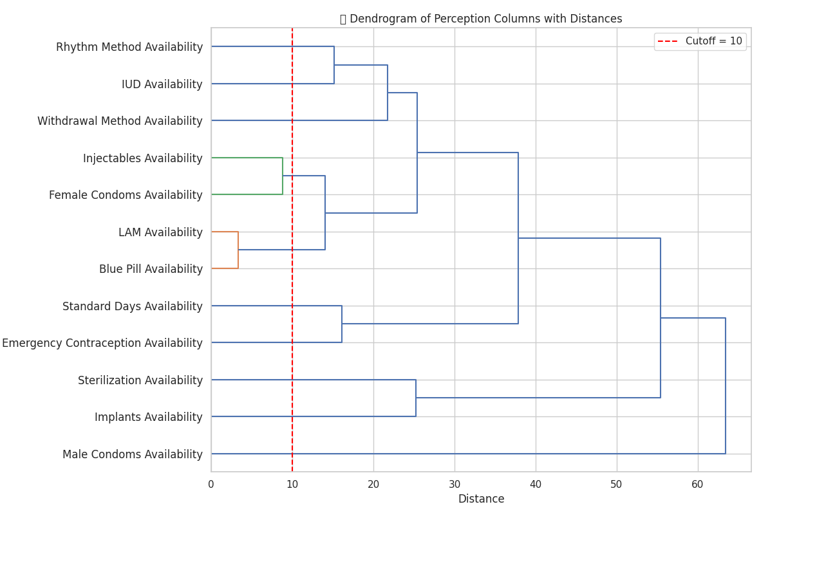

This is a hierarchical clustering dendrogram of perceptions of the contraceptive method availability or usage.

Each Horizontal line represents the distance at which two clusters (or methods) are joined. The vertical line connects this merges.

**HOW TO READ IT**

1. **Left to Right: Clustering Process**

* Each label on the left represents the availability of a contraceptive
* As you move to the right, contraceptives with similar availability patterns are merged into clusters.
* The more further you move to the right, the more dissimilar the methods being joined together are.

1. **X-Axis Distance**

* This shows the linkage distance.( Euclidian distance between vectors of Likert percentages)
* Longer lines indicates the contraceptives are less similar in perception

1. **Red Dashed Line (Cutoff = 10)**

* This is the pruning line
* It cuts the dendrogram into clusters – anything that merges on the left of this line is considered 1 cluster
* Anything that merges after the line is a separate cluster

**Interpretation**

* LAM Availability and Blue Pill Availability are merged very early – People perceive the availability of these 2 methods similarly.
* Injectables Availability and Female condoms availability also merge very early
* Sterilization availability and Female condoms Availability merge very far from most others – These are perceived very differently than others.